|  |  |
| --- | --- |
| Урок | Реализация |

General

|  |  |
| --- | --- |
| <link href="https://fonts.googleapis.com/css2?family=Montserrat:wght@400;500;600;700&display=swap" rel="stylesheet"> | @import url("https://fonts.googleapis.com/css2?family=Montserrat:wght@400;500;600;700&display=swap"); |
| body {  background: #181E34;  font-family: "Montserrat", "Arial", sans-serif;  line-height: 150%;  color: #fff;  } | body {  background: #181e34;  font-family: "Montserrat", "Arial", sans-serif;  line-height: 150%; /* 16px+50%=24px */  color: #fff;  } |
| .container {  max-width: 930px;  margin: 0 auto;  padding: 0 15px;  height: 100%;  } | .container {  max-width: 930px;  margin: 0 auto;  padding: 0 15px;  height: 100%;  } |

Header

|  |  |
| --- | --- |
| .header {  padding: 30px 0 36px;  } | .header {  padding: 30px 0 36px;  } |
| .header-inner {  display: flex;  align-items: center;  } | .header-inner {  display: flex;  align-items: center;  } |
| .header-nav {  margin-left: auto;  } | .header-nav {  margin-left: auto;  } |
| .header-list {  display: flex;  } | .header-list {  display: flex;  } |
| .header-item {  margin-right: 30px;  } | .header-item {  margin-right: 30px;  } |
| .header-button {  color: #2766AE;  background: #FFFFFF;  border-radius: 100px;  padding: 14px 30px;  font-weight: 500;  } | .heder-button {  color: #2766ae;  background: #fff;  border-radius: 100px;  padding: 14px 30px;  font-weight: 500;  margin-left: 4px;  } |

|  |  |
| --- | --- |
| Урок | Реализация |

Hero

|  |  |
| --- | --- |
| .hero {  padding: 120px 0;  background: url("../img/hero-bg.jpg") 10% 50% / cover no-repeat;  } | .hero {  padding: 120px 0;  background: url("../img/hero-bg.jpg") 10% 50% / cover no-repeat;  } |
| .hero-title {  font-weight: 600;  font-size: 40px;  line-height: 49px;  text-transform: uppercase;  text-align: center;  margin-bottom: 60px;  } | .hero-title {  font-weight: 600;  font-size: 40px;  line-height: 49px;  text-transform: uppercase;  text-align: center;  margin-bottom: 60px;  } |
| .hero-inner {  display: flex;  align-items: center;  justify-content: space-between;  } | .hero-inner {  display: flex;  align-items: center;  justify-content: space-between;  } |
| .hero-text {  max-width: 436px;  } | .hero-text {  max-width: 436px;  } |
| .hero-text span {  text-transform: uppercase;  font-weight: 700;  color: #01A2CB;  } | .hero-text a {  text-transform: uppercase;  font-weight: 700;  color: #01a2cb;  } |
| .paragraph {  margin-bottom: 15px;  } | .hero-text p {  margin-top: 15px;  } |
| - | .hero-text p:first-child {  margin-top: 0px;  } |
| .hero-buttons {  display: flex;  flex-direction: column;  width: 100%;  max-width: 320px;  } | .hero-buttons {  display: flex;  flex-direction: column;  width: 100%;  max-width: 320px;  } |
| .hero-button-one,  .hero-button-two {  border-radius: 100px;  padding: 18px 30px;  display: flex;  justify-content: center;  } | .hero-button-one,  .hero-button-two {  border-radius: 100px;  padding: 18px 30px;  display: flex;  justify-content: center;  } |
| .hero-button-one img,  .hero-button-two img {  margin-left: 4px;  } | .hero-button-one img,  .hero-button-two img {  margin-left: 4px;  } |
| .hero-button-one {  background: linear-gradient(180deg, #00A4CC 0%, #2766AE 100%);  } | .hero-button-one {  background: linear-gradient(180deg, #00A4CC 0%, #2766AE 100%);  } |
| .hero-button-two {  background: linear-gradient(95.22deg, #00A4CC 6.7%, #2766AE 91.35%);  } | .hero-button-two {  background: linear-gradient(95.22deg, #00A4CC 6.7%, #2766AE 91.35%);  } |
| .margin-bottom {  margin-bottom: 10px;  } | .mb10 {  margin-bottom: 10px;  } |

Cards

|  |  |
| --- | --- |
| .cards {  padding: 120px 0;  } | .cards {  padding: 120px 0;  } |
| - | .title-inner {  display: flex;  flex-direction: column;  justify-content: center;  max-width: 513px;  margin: 0 auto;  } |
| .cards-title {  font-weight: 600;  font-size: 40px;  line-height: 49px;  text-transform: uppercase;  text-align: center;  margin-bottom: 15px;  } | .cards-title {  font-weight: 600;  font-size: 40px;  line-height: 49px;  text-transform: uppercase;  align-self: center;  } |
| .cards-text {  text-align: center;  max-width: 513px;  margin: 0 auto 60px;  } | .title-inner p {  text-align: center;  margin-top: 15px;  } |
| .cards-flex {  display: flex;  flex-wrap: wrap;  margin: 0 -14px;  margin-bottom: -28px;  padding-bottom: 30px;  } | .cards-flex {  display: flex;  flex-wrap: wrap;  justify-content: center;  margin: 60px 0 2px;  } |
| .cards-flex-item {  margin-bottom: 28px;  padding: 0 14px;  flex: 0 0 25%;  } | .cards-flex-item {  margin-bottom: 28px;  margin-left: 28px;  display: flex;  flex-direction: column;  align-items: center;  max-width: 204px;  background: #197cb8;  box-shadow: 4px 4px 13px 0px rgba(11, 15, 30, 0.79);  border-radius: 16px;  padding: 28px;  } |
| .cards-flex-inner {  background: #197CB8;  border: 2px solid #176BAE;  box-shadow: 4px 4px 13px rgba(5, 13, 41, 0.76);  border-radius: 16px;  padding: 28px 15px;  } |  |
| .cards-flex-title {  font-weight: 600;  font-size: 22px;  line-height: 27px;  text-transform: uppercase;  margin-bottom: 10px;  text-align: center;  } | .cards-flex-item h3 {  font-weight: 600;  font-size: 22px;  line-height: normal;  text-transform: uppercase;  } |
| .cards-flex-text {  text-align: center;  } | .cards-flex-item p {  text-align: center;  margin-top: 10px;  } |
| .cards-button {  display: block;  border-radius: 100px;  padding: 18px 30px;  background: linear-gradient(180deg, #00A4CC 0%, #2766AE 100%);  text-align: center;  max-width: 436px;  margin: 0 auto;  } | .card-button-one {  display: block;  border-radius: 100px;  padding: 18px 30px;  background: linear-gradient(180deg, #00a4cc 0%, #2766ae 100%);  text-align: center;  max-width: 436px;  margin: 0 auto;  } |
| - | /* Отменяем левый отступ */  .margin-left {  margin-left: 0px;  } |

HTML - Cards

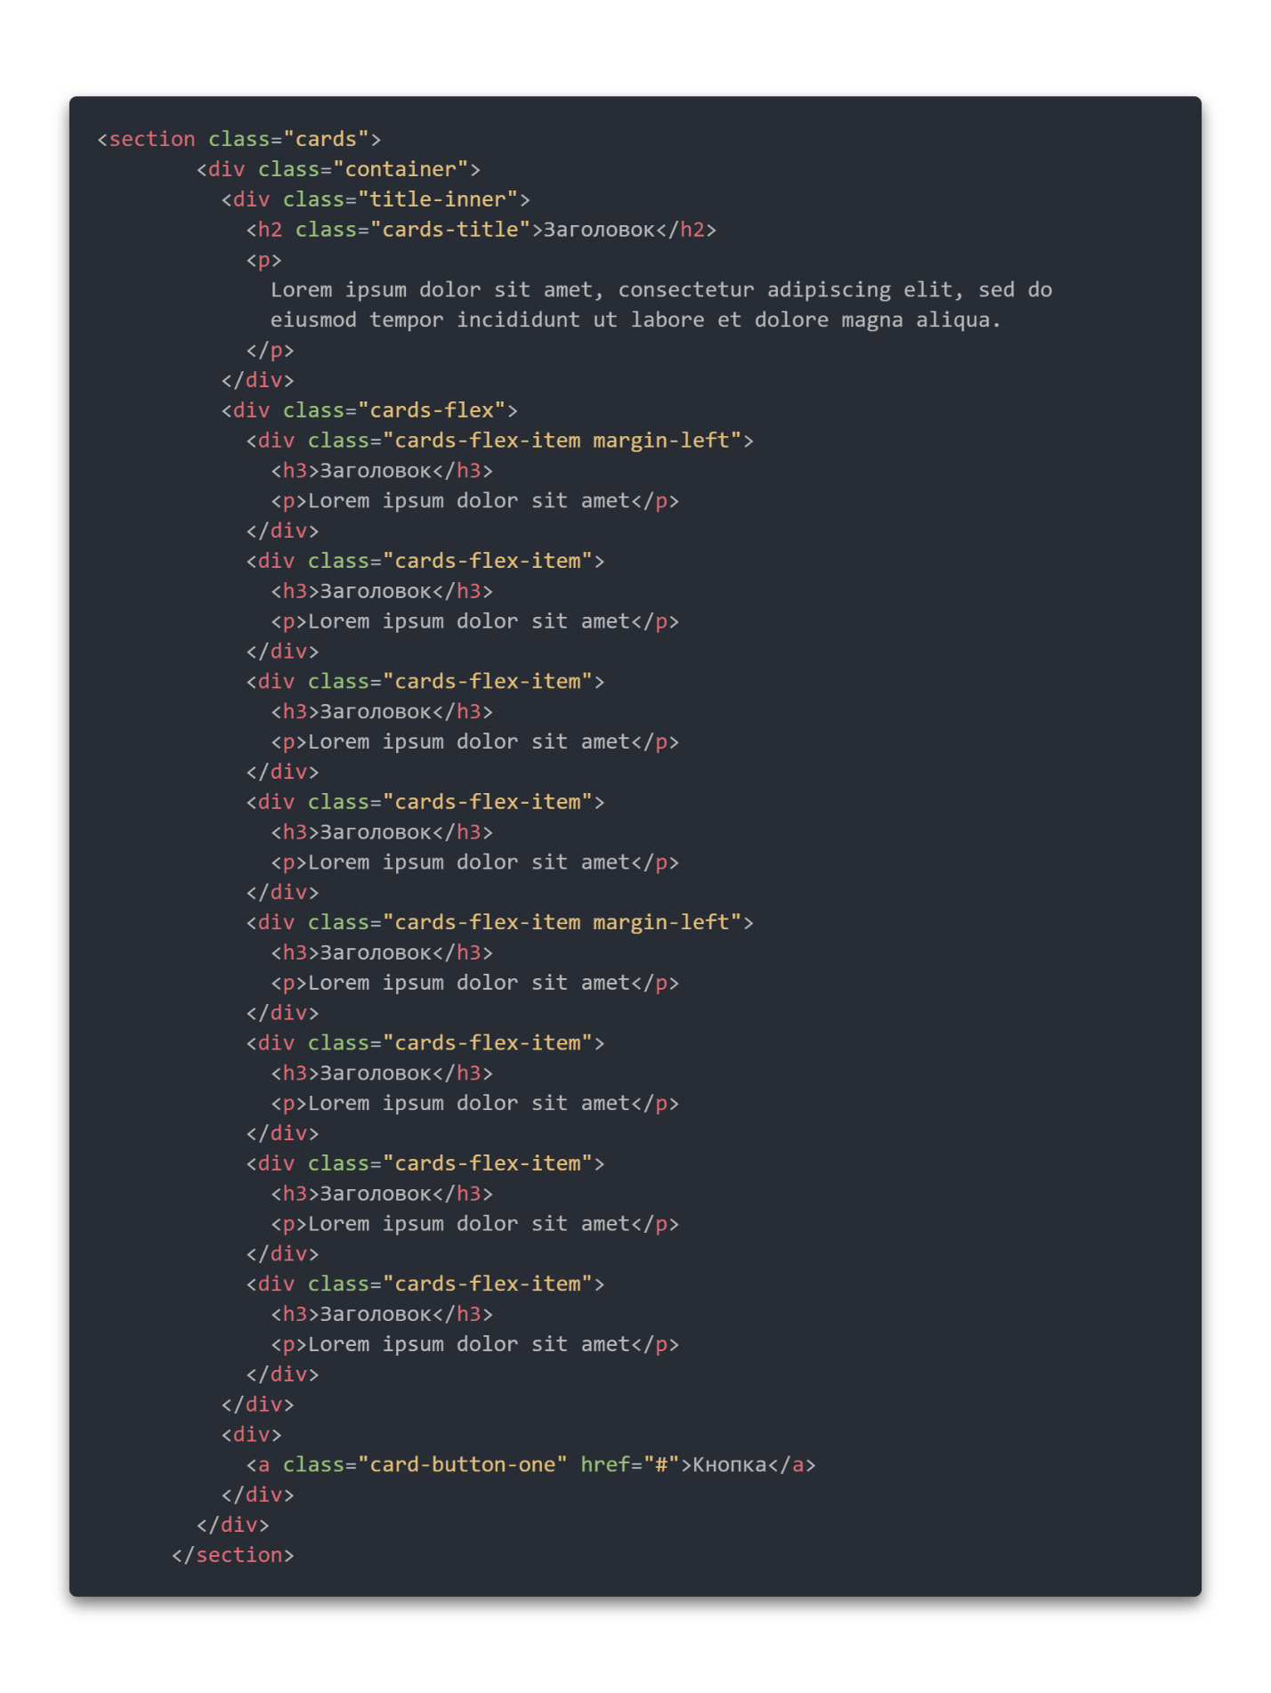

Footer

|  |  |
| --- | --- |
| .footer {  border-top: 1px solid #323952;  padding: 60px 0;  } | .footer {  border-top: 1px solid #323952;  padding: 60px 0;  } |
| .footer-inner {  display: flex;  } | .footer-inner {  display: flex;  } |
| .footer-desc {  max-width: 267px;  margin-right: auto;  } | .footer-desc {  max-width: 267px;  margin-right: auto;  } |
| .footer-desc a {  display: inline-block;  margin-bottom: 15px;  } | .footer-desc a {  display: inline-block;  margin-bottom: 15px;  } |
| .footer-col {  max-width: 204px;  width: 100%;  } | .footer-col {  max-width: 204px;  width: 100%;  } |
| footer-col-margin {  margin-right: 28px;  } | footer-col-margin {  margin-right: 28px;  } |
| .footer-title {  font-weight: 600;  font-size: 22px;  line-height: 27px;  text-transform: uppercase;  margin-bottom: 20px;  } | .footer-title {  font-weight: 600;  font-size: 22px;  line-height: 27px;  text-transform: uppercase;  margin-bottom: 20px;  } |
| .footer-item {  margin-bottom: 10px;  } | .footer-column li {  margin-bottom: 10px;  } |